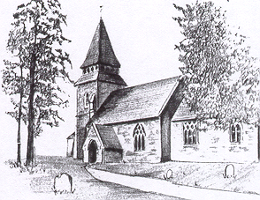

***KENTCHURCH PARISH COUNCIL***

**Biodiversity and Crime and Disorder Policy**

Kentchurch Parish Council works hard to maintain the rural atmosphere of its historical village through consultation and engagement with residents and village organisations.

The Parish Council promotes schemes and devises projects that encourage people to plant trees, shrubs and hedges, tidy neglected areas and plant flowers.

Several policies are in place for reducing crime including:-

1. Neighbourhood Watch Bulletins are published on the website
2. PCSOs attend Parish Council meetings (when work commitments allow) where residents can also share their concerns.

Leadership in planning for the future of the community with the Parish Council’s paperless planning system.

The Planning Working Group meets when necessary dealing with non-contentious planning applications in a timely manner, with the Parish Council having the ultimate authority.

The Parish Council’s Planning Working Group looks at planning applications with a view to driving out crime.

Members of the public regularly attend the Parish Council Meetings and send their comments and a representative from the Parish Council is permitted to speak at the Herefordshire Council Planning Meetings.

Herefordshire Council has a Local Development Plan 2011 – 2031.

**Performance of the Council as a Corporate Body**

Kentchurch Parish Council is a body of five Parish Councillors and operates through a Working Group System with regular meetings for Planning Applications.

Finance meetings reporting that the Parish Council is working within budget and costs are regularly monitored at a Finance Working Group meeting.

The Clerk is employed under the terms jointly negotiated with NALC / HALC and the Parish Council has excellent systems in place to manage Clerk induction, appraisals and training.

The Clerk gives guidance to all Parish Councillors at Parish Council meetings.

Parish Council Chairman Mr John L Pring

Signed…………………………………………………..

Date 20th July 2016